**Steps to run JDBC**

1. Download XAMPP from [Apache Friends](https://www.apachefriends.org/index.html) and install in E:\drive.
2. Open XAMPP Control Panel and start Apache and Mysql
3. Open your web browser and type in: [**http://localhost**](http://localhost/), you will get

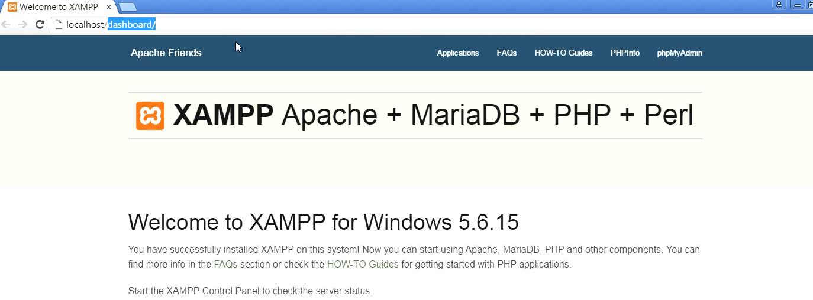

1. Click on phpMyAdmin to open . Create database and table and enter few data.
2. Download Java MySQL Connector *‘mysql-connector-java-5.1.48-bin.jar’* and keep it on the desktop **(Download xampp-mysql version compatible jar file)**
3. **Create a Java project in Eclipse IDE**

* Open Eclipse IDE. Create a new Java Project and name it as “mydbproj”.

1. **Configure JDBC driver in Eclipse IDE**

* You need to add the downloaded Java MySQL Connector JAR in client **project’s classpath**. To do this,**right click on your Java Project (mydbproj) -> Properties -> Buildpath -> Libraries -> Add External JAR and select “mysql-connector-java-5.1.34-bin.jar” JAR file**.

1. **Set up a simple database program**

**import** java.sql.*;

**public** **class** JdbcExample {

**public** **static** **void** main(String args[]) {

Connection con = **null**;

**try** {

Class.*forName*("com.mysql.jdbc.Driver").newInstance();

con = DriverManager.*getConnection*("jdbc:mysql://localhost:3306/mydb", "root", "");

**if** (!con.isClosed())

System.***out***.println("Successfully connected to MySQL server...");

} **catch**(Exception e) {

System.***err***.println("Exception: " + e.getMessage());

} **finally** {

**try** {

**if** (con != **null**)

con.close();

} **catch**(SQLException e) {}

}

}}

1. **Run the program ->click on Java file -> RunAs-> Java Application. You will get the following output.**

Successfully connected to MySQL server...

2. Program to display the contents of mysql table

import java.sql.*;

public class mysql_demo{

public static void main(String[] args) {

System.out.println("MySQL Connect Example.");

Connection conn = null;

String url = "jdbc:mysql://localhost:3306/";

String dbName = "mydb";

String driver = "com.mysql.jdbc.Driver";

String userName = "root";

String password = "";

String f1,f2;

try {

Class.forName(driver).newInstance();

conn = DriverManager.getConnection(url+dbName,userName,password);

String query = "Select * FROM stud";

System.out.println("Connected to the database");

Statement stmt = conn.createStatement();

ResultSet rs = stmt.executeQuery(query);

while (rs.next())

{

f1 = rs.getString(1);

f2 = rs.getString(2);

System.out.println(f1+" "+f2);

} //end while

conn.close();

System.out.println("Disconnected from database");

} //end try

catch(ClassNotFoundException e) {

e.printStackTrace();

}

catch(SQLException e) {

e.printStackTrace();

}

catch (Exception e) {

e.printStackTrace();

}

}

}

3. Program to insert data into the table and display the contents.

import java.sql.*;

import java.io.*;

class JDBC_prepared_ins_ex{

public static void main(String args[])throws Exception{

System.out.println("MySQL Connect Example.");

Connection conn = null;

String url = "jdbc:mysql://localhost:3306/";

String dbName = "mydb";

String driver = "com.mysql.jdbc.Driver";

String userName = "root";

String password = "";

Class.forName(driver).newInstance();

conn = DriverManager.getConnection(url+dbName,userName,password);

System.out.println("Connected to the database");

String myusn,myname;

PreparedStatement ps=conn.prepareStatement("insert into stud values(?,?)");

Statement stmt = conn.createStatement();

BufferedReader br=new BufferedReader(new InputStreamReader(System.in));

do{

//int id=Integer.parseInt(br.readLine());

//float salary=Float.parseFloat(br.readLine());

//ps.setFloat(2, salary);

System.out.println("enter usn:");

myusn=br.readLine();

System.out.println("enter name:");

myname=br.readLine();

ps.setString(1,myusn);

ps.setString(2,myname);

int i=ps.executeUpdate();

System.out.println(i+" records added");

System.out.println("Do you want to continue: y/n");

String s=br.readLine();

if(s.startsWith("n")){

break;

}

}while(true);

String sql = "SELECT * from stud";

ResultSet rs = stmt.executeQuery(sql);

System.out.println("The records are :");

while (rs.next())

{

myusn = rs.getString(1);

myname=rs.getString(2);

System.out.println(rs.getRow()+"-"+myusn+" "+myname);

} //end while

conn.close();

}}